**Data Visualization**

**“Aid Worker Security”**

Submitted By:

Shreya Singh

([shreya.singh@sjsu.edu](mailto:shreya.singh@sjsu.edu))

**Acknowledgment**:

I would like to thank the professor for his guidance and support throughout the project.

His expertise and insights were invaluable in helping to understand the concepts and

techniques used in data visualization.

**Project Proposal:**

My final term project:

**“Aid Worker Security”**

[Attacks against aid workers](https://en.wikipedia.org/wiki/Attacks_on_humanitarian_workers) recorded in the AWSD are defined as "major", including intentional killings, kidnappings, serious sexual assault/rape, and attacks causing serious injury. The definition of an aid worker is also limited to those working in emergency contexts to provide [humanitarian relief](https://en.wikipedia.org/wiki/Humanitarian_aid) (as opposed to political, developmental or other assistance). The aid worker victims are employees, or contractors and consultants, of [not-for-profit aid agencies](https://en.wikipedia.org/wiki/Nonprofit_organization).

The dashboard will include a variety of visualizations that allow users to explore the data in different ways. There will be the interactive dashboard where the graphs will be interactive to another one, i.e. on selecting one type of data, it will automatically display the information related to that type of data in the another graph(here , it will filter out the data on select Action)

The final dashboard will be presented in class and will be accessible to anyone with an

interest in the same. It will be updated regularly with the latest data, ensuring that it

remains a valuable and relevant tool for exploring and analyzing data.

This project will be valuable for the organizations and Governments to track all the data in a visual manner, analyze the data and provide the better working environments for the aid workers, which ultimately resulting to t he better services/humanitarian aids to the needy.

**Introduction**:

The purpose of this project is to create a Tableau dashboard that visualizes data related to Aid Workers Security.

This is one of the most suppressed issues, and through my work, I hope, I will be able to spread awareness among people , NGOs and government bodies and be the voice of these humanitarian heroes, whose security is essential.

**About the Data:**

I have downloaded the data from:

https://aidworkersecurity.org/

The Aid Worker Security Database (AWSD) records major incidents of violence against aid workers, with incident reports from 1997 through the present. Initiated in 2005, to date the AWSD remains the sole comprehensive global source of these data, providing the evidence base for analysis of the changing security environment for civilian aid operations.

This data includes many detailed information like- Number of Affected people, countries, city, details type of attacks, its context and much more.

In this report, we will describe the data sources and cleaning process, as well as the

design and implementation of the Tableau dashboard. We will also provide examples of

the visualizations and discuss the insights that can be gained from the dashboard.

Finally, we will also discuss the future scope.

**Process**:

Once the data was cleaned and organized it was time to create the Dashboard in Tableau where I created different sheets that later came together in a Dashboard and then to a story.

**Dataset Used:**

The datasets were cleaned and organized using Microsoft Excel. This process involved

tasks such as removing duplicates, filling in missing values, and formatting the data in a

consistent way. The cleaning and organization of the datasets was crucial for ensuring that

the data was accurate and usable in the dashboard.

Below is the screenshot of the dataset sheet we have used:

**Sheets in the Tableau:**

Capturing the type of the Incidents :

Total Kidnapped

Total Killed

Total Wounded

#of Incidents happened over the years:

Context : What was the contyect / how the attack was carried out?

Like – was it a mob killing, killing, Ambush, etc.

More drilled down to the kind of attack carried out!

Was the attack of Aerial Bombardment type , or was it a sexual harassment along with the percentage calculated.

The percentage was computed , below is the screenshot below:

Also, created the Action Filter on selecting, where in my workbook:

Dashboard1:

Dashboard 2:

Dashboard 3: Map Visualization:

Here I have used the Annotations with the pointing out to the city, layered with the country and then the city details:

Country wise:

Drilled down more to city:

These dashboards were interactive:

When selected the particular country from the top most countries, it changed the numbers in the # of incidents recorded over the years, and vice versa.

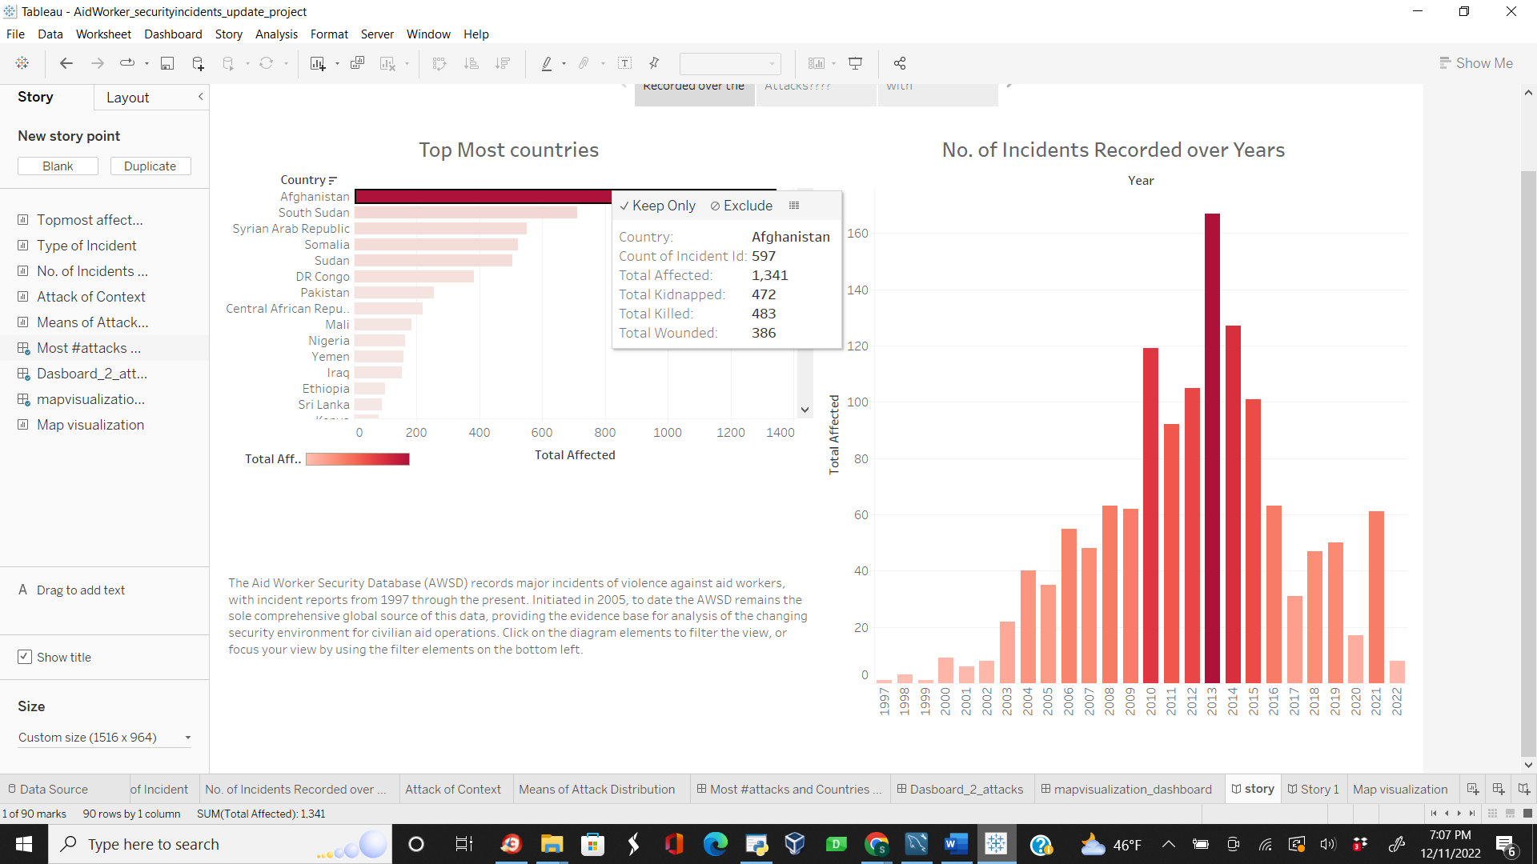

Story Created:

**References**:  
Inspired from:  
Lani He (https://public.tableau.com/app/profile/lani.he)  
Data Downloaded from : <https://aidworkersecurity.org/>